

Data Technician

Name:
Course Date:
Table of contents
Day 1: Task 1 3
Day 1: Task 2 4
Day 1: Task 3 5
Day 1: Task 4 6
Day 2: Task 1 7
Day 2: Task 2 8
Day 2: Task 3 12
Day 3: Task 1 13
Day 3: Task 2: Skillable 14
Day 3: Task 3: Skillable 16
Day 4: Task 1: MS Fabric using Just IT 17
Day 4: Task 2: Skillable 17
Day 4: Task 3 (Optional) 18
1. Scenario Background 18
2. Data Laws and Regulations 18
3. Azure Service Recommendations 18
4. Data Types and Data Modelling 18
5. Data Storage Formats and Structures in Azure 19
6. Additional Considerations 19
Submission Guidelines: 19
Course Notes 22
Additional Information 23

Day 1: Task 1

Please research and complete the below questions relating to key concepts of cloud.

Be prepared to discuss the below in the group following this task.

What can cloud computing do for us in the real-world? | Cloud computing is a way of managing and interacting with our data and applications online. We can store data, manage software and communicate using cloud computing with varying degrees of management and function depending on what service provider we chose to use.
How can it benefit a business? | Cloud computing can reduce resource and maintenance costs as well as make it much easier for a business to upscale or downscale.
What’s the alternative to cloud computing? | The alternative to cloud computing is on site computing. This is the more traditional method of storing data and working with physical servers which can be expensive and not cost effective with scalability.
What cloud providers can we use, what are their features and functions? | The three main cloud providers are Amazon, Google and Azure (Microsoft). They can provide a variety of online features for a business such as storage, networking, online applications as well as AI functionality.

Day 1: Task 2

Pricing Calculator: In this exercise, you use the Pricing calculator to estimate the cost of running a basic web application on Azure.
Exercise - Estimate workload costs by using the Pricing calculator - Training | Microsoft Learn

Cost of a basic web application | $2,078.56 per month

Day 1: Task 3

Please research the below cloud offerings, explain what they are and examples of use cases.

Cloud Offerings | Explain what it is | When / how might you use this service in the real-world?
IaaS (Infrastructure as a service) | IAAS (infrastructure as a service) is a cloud service that lets you manage everything yourself such as your data, applications and operating systems. | IaaS is used when you want maximum control over your cloud systems as it allows for the most functionality and features compared to Paas or Saas. This makes it a good choice for businesses.
PaaS (Platform as a service) | PAAS (platform as a service) means you must only manage applications and data, and everything is managed by the provider. | Paas would be used for software developers and programmers looking to primarily focus on developing and modifying their own software and applications without needing to spend too much time on any other factors.
SaaS (Software as a service) | SAAS (software as a service) is a service that manages everything for you. All its features are managed by the provider, so users automatically gain access to prebuilt ready-to-use features. | Saas is primarily used by individuals and employees as all the features and functionality are managed by the providers. Meaning that users will have all the features they need without any technical busy work.

Day 1: Task 4

Please research the below terms and explain what they are, when they would be appropriate and a real-world example of where it could be implemented (i.e. what type of organisation).

Public Cloud | A public cloud is a cloud service that’s managed by an organisation and available on the internet to the public. This means something like a retails store with an online presence to sell their merchandise via delivery.
Private Cloud | A private cloud is a cloud service that only available to the organisation that manages it. An organisation would use this as a private space with which their business operates. It could be a finance company using it to securely store and manage the personal details of their customers.
Hybrid Cloud | A hybrid cloud is a cloud service with the functionalities of both a public cloud and private cloud. A business can use this cloud model to provide a public service while maintaining a private online presence at the same time. For example, a bank can privately and securely store the personal and financial details of their customers while also providing an online service to allow their customers to access their money.
Community Cloud | A community cloud is like a private cloud but rather than being purely for one organisation, it’s shared across several different third parties. This is good for different locations that share the umbrella company. For example, different government bodies and departments will use a community cloud to communicate and coordinate with each other.

Day 2: Task 1
You are a Cloud Consultant hired by a client. You will identify the most suitable cloud service model for a client requiring control over infrastructure, estimate potential cloud costs, and explain the benefits of cloud adoption.
🏭 Client – "DataCore Enterprises"
- A large enterprise wants to move its internal database servers to the cloud.
- They already have IT staff.
- They want full control over operating systems and storage configuration.
Questions for you:
- Which service model suits them? (IaaS, PaaS, Saas)
The IaaS cloud model is best suited as it provides the user the most flexibility and control.
- How can they estimate the cost of using cloud services?
By using an online pricing calculator to calculate the cost of each component of the service they need.
- What are the possible benefits of using cloud services?
Since you don’t need on premise equipment such as servers, the maintenance and set up costs will be reduced. It will also be cheaper because unlike a physical server, you would only pay for it when you are using it. Cloud services also allow for greater flexibility and ease when upscaling and downscaling.

- Bonus: What might be potential risks?
Cyber security may be a potential risk. Since all the data is in an online cloud service, it could open it up to the heightened risk of a cyber-attack. Also, when using a cloud service, you are rather reliant on the provider. This could lead to something like unexpected downtime. Though there is a minimal risk of this, it's still worth bearing in mind.

Day 2: Task 2

Describe, with examples, the three major areas that the Computer Misuse Act deals with.

Area | Description | Example
Unauthorised access to computer material. | This area means gaining access to computer systems without the owner's knowledge or consent is illegal. | A hacker manages to breach the firewall and other online security measures of a business's systems and accesses their database.
Unauthorised access with intent to commit or facilitate further offences. | This section covers the aftermath of successful unauthorised access. It covers the possibility that someone will commit further crimes as a result of having access to systems they shouldn't. | A hacker may gain unauthorised access to a finance company’s system and plant some ransomware. This would then encrypt the company’s data, and the hacker would demand payment for return of the data.
Unauthorised modification of computer material | This means a criminal does something to another computer system alters, manipulates or impairs the way it functions in some way without the owner's knowledge or consent. | Though the use of a fake website made to look like a legitimate website, a criminal can trick users into following a link on this site which secretly plants some kind of malware onto the user's system.

The computer misuse act 1990 is an act where an individual can be criminalised because of computer related offense. Describe three extra powers that the Police and Justice Act 2006 (Computer Misuse) has added.

Description
The act criminalised the creation, distribution and use hacking tools. This means that if someone interacts with hacking tools in some way (even if it’s just supplying them to someone else), then it is punishable by law.

The act also covers DOS (denial of service) attacks and makes them a criminal offence. This means to flood on online system with data in an attempt to damage and disable it, denying its usage to other users.

Another added power is the expansion of the territorial scope of the act. This means that should a criminal commit on offence overseas that is punishable by this act, then they still must face justice for it.

Look at the below website to answer the questions:
https://www.gov.uk/personal-data-my-employer-can-keep-about-me

Write down three items of data which a company can store about an employee.
Name

Address

Date of birth

Give three more examples of data that an employer can only store if they first get the employee’s permission.
Religion

Genetics

Health and medical conditions

Conduct further research to answer the below questions.

Question | Answer
Provide one example of: Copyright infringement | Illegally downloading a movie from an unauthorised website.
Provide one example of: Plagiarism | If you're writing a book but part of it is too similar to someone else's work.
What are two consequences of copyright infringement and software piracy? | One consequence is that the business can face large fines that they would need to pay to the original copyright holder. Theres also the possibility of reputational damage to the company as a result of being caught up in criminal activity.
Give three possible consequences for individuals when using pirated software | Firstly, pirated software is often used by (or targeted by) cyber criminals for them to perform their illegal activities such as spreading malware. Secondly, pirated software can also be quite buggy and lack the customer support needed to resolve its issues. Thirdly, the risk legal charges are just as bigger risk to an individual as it is to a business.

Listed below are some laws which we have covered today:

1. Computer Misuse Act 1990
2. Police and Justice Act 2006 (Computer Misuse)
3. Copyright, Designs and Patents Act 1988
4. Copyright (Computer Programs) Regulations 1992
5. The Health and Safety (Display Screen Equipment) Regulations 1992
6. Data Protection Act 2018
7. Consumer Rights Act 2015

- Insert a number in the first column of each row to match each of the statements with one of the above Acts.

- One of statements is incorrect and not illegal. For this statement, write ‘Not illegal’.

Act number | Clause
3 | With some exceptions, it is illegal to use unlicensed software
7 | Any product, digital or otherwise, must be fit for the purpose it is supplied for
1 | Unauthorised modification of computer material is illegal
Not illegal | It is illegal to create or use a hacking tool for penetration testing
6 | Personal data may only be used for specified, explicit purposes
5 | Employers must provide their computer users with adequate health and safety training for any workstation they work at
2 | It is illegal to distribute hacking tools for criminal purposes
3 | It is illegal to distribute an illicit recording
6 | Personal data may not be kept longer than necessary
1 | Gaining unauthorised access to a computer system is illegal
5 | Employers must ensure that employees take regular and adequate breaks from looking at their screens
1 | It is illegal to prevent or hinder access (e.g. by a denial-of-service attack) to any program or data held in any computer
6 | Personal data must be accurate and where necessary kept up to date

Day 2: Task 3

Please complete this activity to the best of your ability. This is an introduction to Azure Cloud Computing. You can skip Exercises as we will complete day later.
Introduction to Cloud Infrastructure: Describe Azure Architecture and Services - Training | Microsoft Learn

Day 3: Task 1

Please complete the below lab (1) ‘Explore relational data in Azure’ and paste evidence of the completed lab in the box provided.



Completed lab | 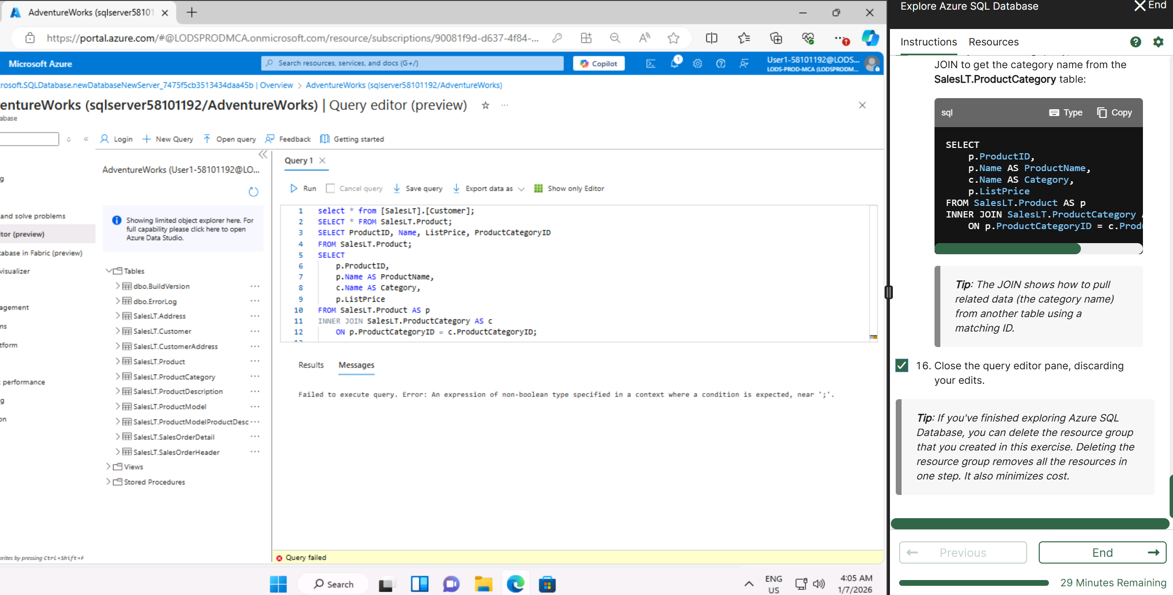

Day 3: Task 2: Skillable
Complete below exercises in lab environment using AdventureWorks DB.
You can view Schema Design here.
-- 1. Customers with last names starting with 'A'
-- Scenario: The marketing department is preparing a campaign targeting customers whose last names begin with the letter 'A'. They need a list of these customers to personalize outreach messages.

select *
From [SalesLT].[Customer]
Where Lastname like 'A%';

-- 2. Customers with first name starting with 'A' and last name ending with 'a'
-- Scenario: The CRM team is analyzing customer name patterns for personalization strategies. They're particularly interested in users with a first name starting with 'A' and a last name ending in 'a'.

select *
From [SalesLT].[Customer]
Where Firstname like 'A%' and Lastname like '%a';

-- 3. Count of customers with first name starting with 'A' and last name including 'o'
-- Scenario: A data analyst is generating statistics for a name segmentation report and needs to count how many customers meet both criteria: first name starts with 'A' and last name contains the letter 'o'.

Select count(*)
From [SalesLT].[Customer]
Where FirstName like 'A%' and LastName like '%o%';

-- 4. Top 3 black products of size 'S' ordered by list price
-- Scenario: The merchandising team is curating a list of 'Black' colored products in size 'S' for a limited-time promotion. They want to showcase the top 3 most affordable options first.

SELECT TOP 3 ProductID, Name, Color, Size, ListPrice
From [SalesLT].[Product]
Where Color = 'Black' and Size = 'S'
Order by ListPrice desc;

-- 5. Average standard cost of products
-- Scenario: The finance team is calculating the average standard cost across all products to assess baseline production expenses.
Select AVG(ListPrice)
From [SalesLT].[Product];

-- 6. Difference between average standard cost and average list price
-- Scenario: The pricing strategy team is examining the average markup between the standard cost and the list price to evaluate profitability trends.

Select avg([SalesLT].[Product].ListPrice) - avg([SalesLT].[SalesOrderDetail].UnitPrice)
From [SalesLT].[Product]
Inner join [SalesLT].[SalesOrderDetail] On [SalesLT].[Product].ProductID = [SalesLT].[SalesOrderDetail].ProductID;

-- 7. Product with highest profit margin
-- Scenario: Management wants to identify the most profitable product by finding the item with the highest difference between list price and standard cost.

SELECT TOP 1 Name, ListPrice - StandardCost AS PriceDifference
FROM SalesLT.Product
ORDER BY PriceDifference DESC;

-- 8. Number of products per category
-- Scenario: Inventory control needs a summary of how many products exist in each product category to manage stock levels effectively.

SELECT c.Name, COUNT(p.Name) AS Total
FROM SalesLT.Product AS p
INNER JOIN SalesLT.ProductCategory AS c
ON p.ProductCategoryID = c.ProductCategoryID
GROUP BY c.Name
ORDER BY Total DESC;

-- 9. Average list price by category
-- Scenario: The product pricing team is reviewing average list prices by category to adjust pricing strategies and identify outliers.

SELECT ProductCategoryID, AVG(ListPrice) AS AveragePrice
FROM SalesLT.Product
GROUP BY ProductCategoryID;

-- 10. Orders with customer information
-- Scenario: The operations team needs a comprehensive report of customer orders, including order details and basic customer info, to review sales performance.
SELECT soh.SalesOrderID, c.CustomerID, c.FirstName, c.LastName, soh.OrderDate, soh.TotalDue
FROM SalesLT.SalesOrderHeader soh
INNER JOIN SalesLT.Customer c ON soh.CustomerID = c.CustomerID;

-- 11. Products priced above average list price
-- Scenario: The sales team wants to identify premium products that are priced above the average list price for highlighting in high-end marketing campaigns.

SELECT ProductID, Name, ListPrice
FROM SalesLT.Product
WHERE ListPrice > (SELECT AVG(ListPrice) FROM SalesLT.Product);

-- 12. Total quantity sold per product
-- Scenario: The business intelligence team is evaluating product performance by analyzing the total quantity sold for each product across all orders.

SELECT p.ProductID, p.Name, SUM(sod.OrderQty) AS TotalQuantitySold
FROM SalesLT.SalesOrderDetail sod
INNER JOIN SalesLT.Product p ON sod.ProductID = p.ProductID
GROUP BY p.ProductID, p.Name;

-- 13. Total sales per customer
-- Scenario: The customer success team wants to calculate the total value of orders placed by each customer to identify high-value clients for loyalty programs.

SELECT c.CustomerID, c.FirstName, c.LastName, SUM(soh.TotalDue) AS TotalSales
FROM SalesLT.SalesOrderHeader soh
INNER JOIN SalesLT.Customer c ON soh.CustomerID = c.CustomerID
GROUP BY c.CustomerID, c.FirstName, c.LastName;

Day 3: Task 3: Skillable

Please complete the below lab (4) ‘Explore non-relational data in Azure’ and paste evidence of the completed lab in the box provided.



Completed lab | 